Memorandum
To: ABC Inc. Accounting Files
From: Sue Wu, Accounting Policy team
Date: 8/31/24
Re: Accounting for Software Capitalization and Measurement
Facts
In March 2024, the management team, finance team, and IT team discussed what NetSuite configuration was needed to achieve to improve efficiency for the company operation and selected Deloitte to assist in the development and implementation of NetSuite.
From April to August 2024, Deloitte provided services for system development with a total of $55K consulting fee, and ABC Inc. purchased a NetSuite license for a total of $25k to obtain access for the internal team, Deloitte, and a small consulting firm to develop and convert data. We provided employee training costs of a total of $10K and hired a small consulting firm for $10k to convert old data for the new system in August 2024.
On September 1st, the NetSuite system implementation was completed and was ready for use. We entered an agreement with NetSuite, including software license, hosting service, and maintenance services, total $60k annually (Standalone price for software licenses $40k, hosting service $20k, and maintenance service $10k annually).
Issues
- Does the NetSuite implementation process involve a capitalized amount?
- How can we measure the September contract with multiple services?
Analysis -Issue 1: Does the NetSuite implementation process involve a capitalized amount?
FASB Accounting Standards Codification (ASC) 350-40, Intangibles-Goodwill and Other, Internal-Use Software provides the following scope guidance.
Internal-Use Software
According to ASC 350-40-55-1, it provides examples of whether computer software is for internal use. For example, an entity purchases or develops software to process payroll, accounts payable, and accounts receivable.
ABC Inc. implements the NetSuite system to improve operational efficiency and reduce manual work for the internal team, especially for the marketing and finance teams. We do not have any plans to sell or lease the modification system in the future, which meets the internal use software standards.
Capitalizable costs
1. Preliminary Project Stage
ASC 350-40-25-1 Internal and external costs incurred during the preliminary project stage shall be expensed as they are incurred.
In March 2024, we did not have any capitalizable costs. The company had an internal discussion to plan the implementation.
2. Application Development Stage
ASC 350-40-25-2 Internal and external costs incurred to develop internal-use computer software during the application development stage shall be capitalized.
$55k system development service from Deloitte shall be capitalized.
ASC 350-40-25-3 Costs to develop or obtain software that allows for access to or conversion of old data by new systems shall also be capitalized.
$25k NetSuite license to obtain access shall be capitalized. This license fee is for the internal team, Deloitte, and small consulting firms to develop and convert data.
ASC 350-40-25-5 Data conversion costs, except as noted in paragraph 350-40-25-3, shall be expensed as incurred. The process of data conversion from old to new systems may include purging or cleansing of existing data, reconciliation or balancing of the old data and the data in the new system, creation of new or additional data, and conversion of old data to the new system.
$10k payment to a small consulting firm shall be expensed. The small consulting firm converted old data to the new system, and it did not involve any system development.
3. Post-implementation operation Stage
ASC 350-40-25-6 Internal and external training costs and maintenance costs during the post-implementation operation stage shall be expensed as incurred.
$10k training costs for employees shall be expensed since it did not involve system development, and the training was in the post-implementation stage.
PwC’s Viewpoint further supports guidance on which costs should be expensed or capitalized.
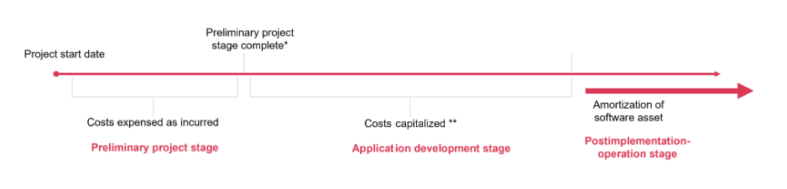
Analysis – Issue 2: How can we measure the September contract with multiple services?
FASB Accounting Standards Codification (ASC) 350-40-30-4, entities may purchase computer software from a third party or may enter a hosting arrangement. In some cases, the price includes multiple elements, such as the license or hosting, training for the software, maintenance fees for routine maintenance work to be performed by the third party, data conversion costs, reengineering costs, and rights to future upgrades and enhancements. Entities shall allocate the cost among all individual elements. The allocation shall be based on the relatively standalone price of the elements in the contract, not necessarily separate prices stated within the contract for each element.
PwC’s Viewpoint provides an example for the measurement as below:
Data Analytics Co agrees with Software Co to license on-premises data analytics software. The contract also includes routine maintenance of the software and training for employees of Data Analytics Co. Additionally, Data Analytics Co. engages the same vendor to perform data conversion and configuration services as part of implementing the new software. The total contract price is $10 million, payable at contract inception.
Software Co offers the software and maintenance services separately for $7 million and $1 million, respectively. Software Co does not offer the training, data conversion, or configuration services separately; however, Data Analytics Co obtained information about pricing from other vendors in the vendor selection process. Data Analytics Co uses this information to estimate standalone prices for the training, data conversion, and configuration of $0.5 million, $2 million, and $1.5 million, respectively.
How should Data Analytics Co account for each element in the agreement?
Analysis
Data Analytics Co should allocate the contract price of $10 million to each of the elements in the contract based on their relative standalone price.
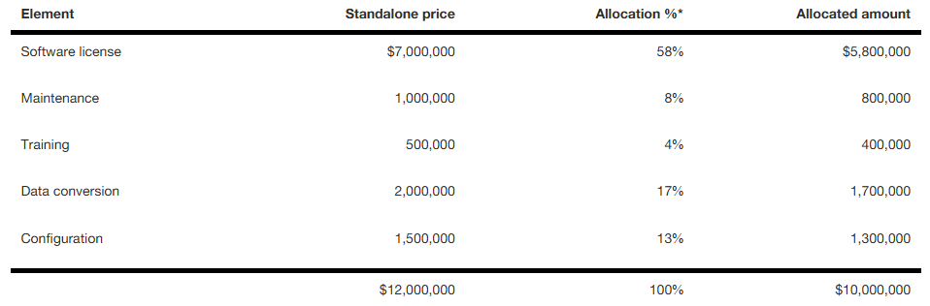
* The allocation percentages have been rounded for presentation purposes.
The amounts allocated to the on-premises software license, as well as the configuration services, should be capitalized in accordance with internal-use software guidance. The amount allocated to maintenance, training, and data conversion services should be expensed as incurred. Because Data Analytics Co pays the total contract price upfront, any amounts prepaid for these services should be initially recognized as a prepaid expense.
Based on the codification and example from PwC, we can calculate as below:
Element Standalone price Allocation % Allocated amount
Software license $40k 57% 34k
Hosting fee $20k 28.6% 17k
Maintenance service $10k 14.4% 9k
Total $ 70k 100% 60k
Conclusion-Issue 1: Capitalized cost
The capitalized cost was a total of $80k including $55k Deloitte consulting fee and $25k
NetSuite access for system development.
Conclusion-Issue 2: Measurement for multiple service contracts
The $60k annual contract was allocated based on relatively standalone prices including
$34k software license, $17k hosting fee, and $9k maintenance service.

